**Galileo Final Project**

Commencement Date: Fall 2019

Research Lecturer (in Singapore): Dr. Kenton Bruce Anderson

University Research Assistants: Khoo Li Wen Gladwys

Sherman Yeow

Toh Chi Han

Manual Last Update: 15/5/2020

**Background**

Galileo is a metric multidimensional scaling approach developed by Joseph Woelfel, used for measuring beliefs and attitudes. The Galileo suite of programs is a social science approach that is considered the most effective in providing a complete engineering solution for planning, conducting, and assessing the impact of communications on attitudes and behaviours.

**Objective**

Our objective is to create a simplified, comprehensive manual regarding the Galileo theory and how it is utilised to collate, measure, and compare results obtained from various studies. Research is mainly focused on finding out people’s perception and understanding of different types of emotions and to measure attitudes. This manual serves as a step-by-step guide to use the Galileo programming software, and raises solutions to previously encountered problems. The solutions provided are not an exhaustive list to all the potential obstacles, and should be taken into account as troubleshoot suggestions.

**Current Status**

As of December 2019, the Galileo software has been used to record answers from questionnaires about emotion categories from University at Buffalo students in Singapore.

1. **Basics**

Important things to note before you get started:

The **user ID** should not exceed 5 characters because it will cause the encoded data to become corrupted when it is transferred to data format. This leads to overlaps in the columns.

Softwares to download:

**Notepad ++**

Download notepad++ from Google, any version of it will suffice.

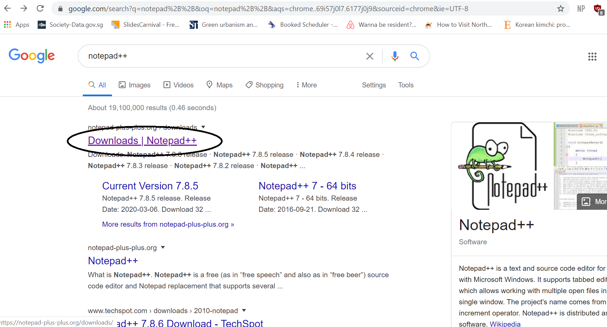

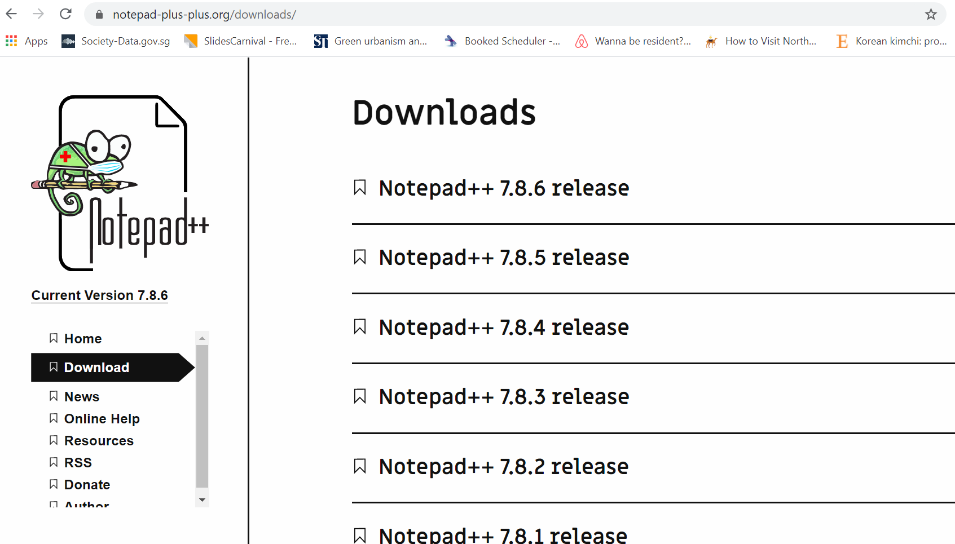

**Galileo Software**

Download the galileo.7z (software) into your device from the “LOOK HERE DOWNLOAD HERE”.Right click on galileo.7z and select extract files to unzip it for usage.

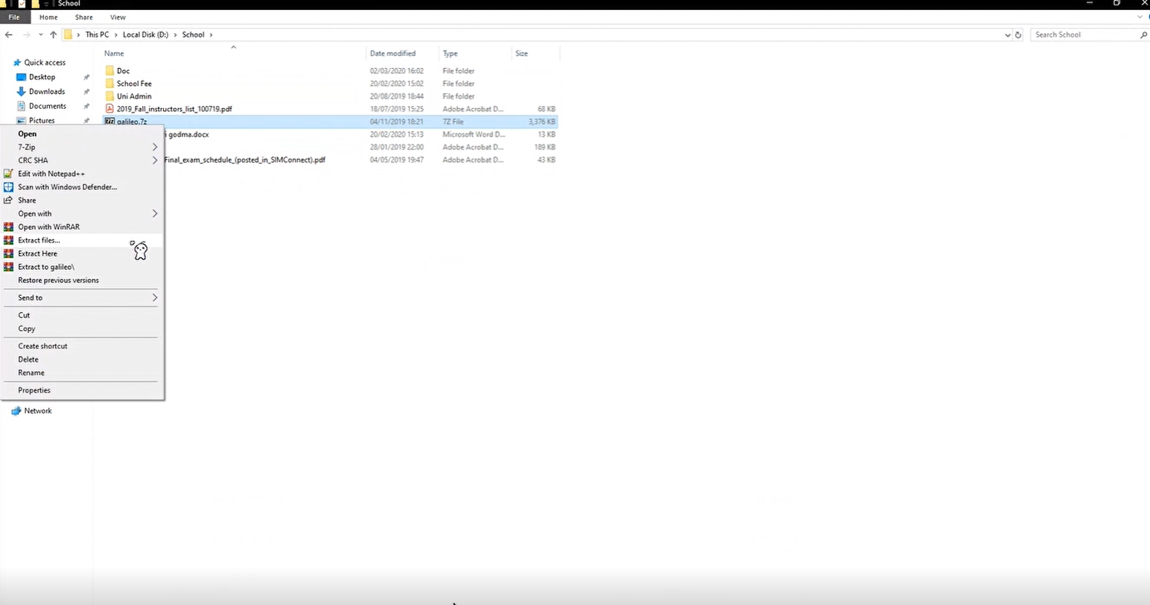

1. **The Guide**

**Step 1:** Upon downloading the software, click on galileo → galileo → running → emos → galileo.dat to delete any data that may exist.

**Step 2:** Next, click on galileo → running → spedx.exe

You will be shown a black screen, follow the instructions on the screen.

**Step 3:** “What is the name of your study directory?” → input “emos” (without the inverted commas).

**Step 4:** “Type in ID” → You will have to refer to the top right hand corner of the survey to get the ID, i.e. 001

**Step 5:** Once that is done, start typing in the answers from the survey. They should either be numbers or blanks.

**Step 6:** Upon completion, open up galileo.dat.

It should open up in **notepad++** andwill contain all of the data that one individual has keyed in.

Example:

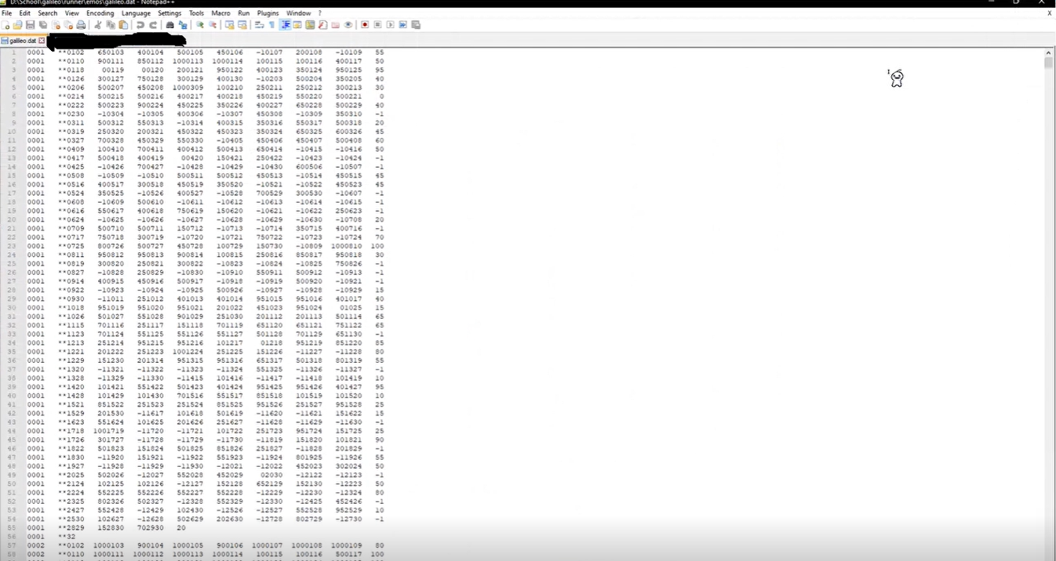

1. **Consolidation**

Appoint one member to do the consolidation. The master copy can be the consolidator’s file. The order of survey records does not matter here, you can choose to consolidate the data in sequential or non-sequential format.

Dropbox

In your Dropbox folder, ‘Galileo Result’ is where you will find and save the data that you have keyed in. It will be sorted according to date → name of individual → the data keyed in.

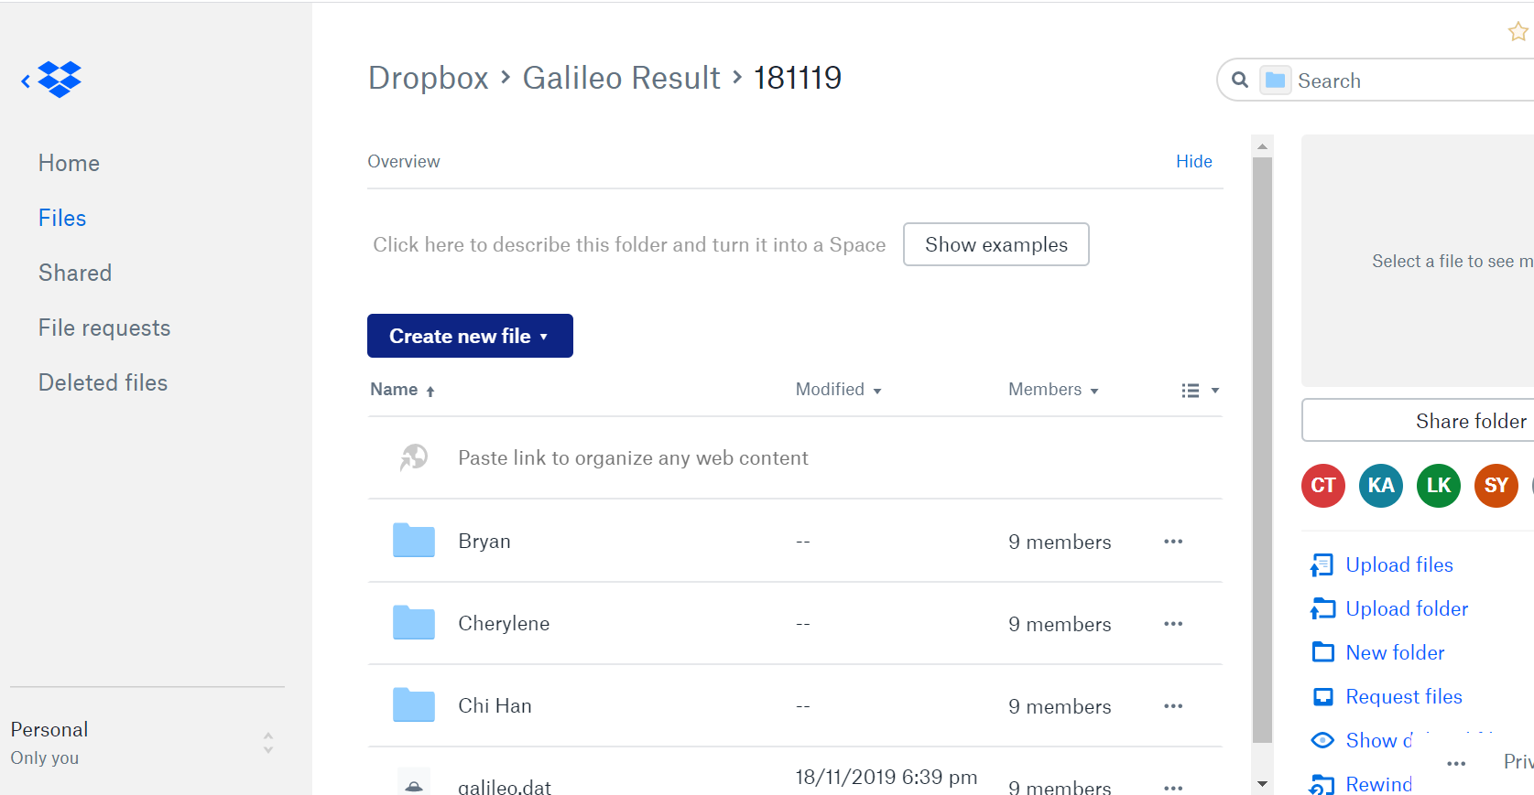

Download **galileo.dat** and it should open up in **notepad++**.

From there, you will be able to view all of the data keyed in by the individual (in the case of the example: Bryan). Copy all of the data recorded by Bryan and transfer it to the **master copy.** Paste it on the next line from the last set of data keyed in.

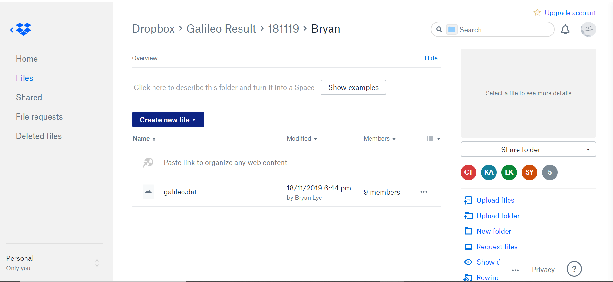

Troubleshoot

You should create a folder for each set of data keyed in by an individual. In the event that you have placed Person A’s keyed-in data into Person B’s name folder, the previous data inside Person B’s folder will be overridden.

For example, if Bryan saves his newly keyed-in data set into Cherylene’s existing folder, the data Cherylene keyed in will be deleted.

1. **Software Removal**

Once done with keying in the data, simply delete all galileo related files and galileo.7z from your computer.